Complex Engineering Problem- 332  
Task: Designing a DC-DC Buck Converter

Shazil Ejaz (*Author)*  
2020456  
FEE(E)GIKI, Topi, Swabi, Pakistan  
u2020456@giki.edu.pk

Syed Usman Shah (*Author)*  
2020486  
FEE(E)GIKI, Topi, Swabi, Pakistan  
u2020486@giki.edu.pk

Haris Javed (*Author)*  
2020301  
FEE(E)GIKI, Topi, Swabi, Pakistan  
u2020301@giki.edu.pk

***Abstract—this report outlines the design process of a DC-DC buck converter that convert 8 V input to 3 V output with less than 0.5% output voltage ripple. The design includes calculating duty ratio, component values, and semiconductor stress. Arduino microcontroller and IR2110 gate driver IC is used for this respective implementation. The design is verified through simulation and measurements on PSIM software.*** ***The circuit was fabricated on a PCB, and measurement points were made available to measure the high side driver gating waveform, voltage across the drain to source of the MOSFET, inductor voltage, and output voltage.***

***Keywords— DC-DC buck converter, power electronics, duty ratio, semiconductor stress, gate driver IC, Arduino, PWM, PCB designing.***

# **I. INTRODUCTION**

DC-DC converters are fundamental building blocks of power electronics circuits and are used to perform various tasks such as voltage level transformation, instrumentation, and impedance matching. Buck converters are widely used in power electronics for their efficiency and simplicity of design. The aim of this report is to present the design process of a DC-DC buck converter, that has the ability to convert an 8 V input to a 3 V output while

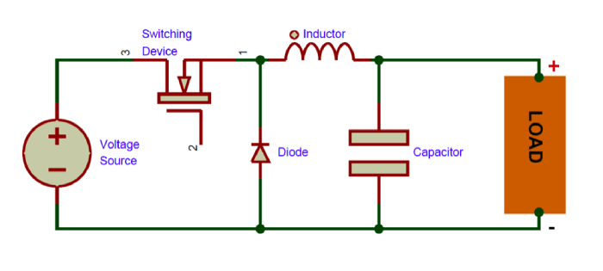keeping the output voltage ripple less than 0.5%. The load connected is a 10Ω resistance with power rating of 20 W. 25 kHz of switching frequency. Primary aim of this document is to provide insights into the complete design process flow of a DC-DC buck converter.

Figure 1 DC-DC Buck Converter

**II. DESIGN PROCESS FLOW**

# **III. COMPONENT CALCULATIONS**

# Calculation of duty ratio

The duty ratio of the buck converter can be calculated using the following equation:

Vout=3V

Vin=8V

# Calculation of Load current

# Calculation of Inductor value

Switching frequency (f)=25 KHz

*L= 1.25 x Lmin (ensuring CCM mode)*

**L=156 uH**

1. Calculating Inductor current ripple

To calculate the maximum ripple current in the inductor, we can use the following formula:

1. Maximum and Minimum Inductor currents
2. Inductor voltage when switch is closed

**Vin-Vout=8-3=5V**

***Therefore 156 uH Inductor, rated for at least 0.54A peak current and 0.33A RMS current. To ensure reliable operation, the inductor should also have a saturation current rating higher than the maximum expected current as well as the rating of the inductor should be at least 5V or higher.***

1. Capacitor value

The capacitor values of the buck converter can be calculated using the following equations:

Vout; maximum allowable ripple voltage on the output:

**0.5% of 3v = 0.015 V**

Thus,

**C=160.2uF**

1. Capacitor Peak Current

1. Capacitor Rating

**Vout= 3V**

***Thus, a 160.2uF capacitor rated for at least 3V voltage and the expected ripple current of 0.138A. For better results, the capacitor should also have a maximum voltage rating higher than the maximum expected voltage.***

1. Switch Stresses Calculations:

From the given information, we can calculate the voltage and current stresses on each semiconductor as follows:

1. **MOSFET:**

When the MOSFET is ON, the drain-source voltage (VDS) is:

**VDS=Vin + Vout = 8V +3V = 11V.**

The maximum current stress through the MOSFET during its ON time (Isw) is calculated as follows:

**Isw = 0.3A + 0.24/2**

**Isw = 0.42A**

***So, the MOSFET should have a voltage rating higher than 11V to handle the maximum voltage stress and have a current rating higher than 0.42A to handle the maximum current stress.***

1. **Diode:**

The diode conducts current (Id) only when the MOSFET is OFF.

**Id = 0.1875A**

Where Id is the maximum current through the diode.

**Vdpeak = Vin=8V**

where Vdpeak is the maximum voltage stress.

***Hence, the voltage stress and current stress for the diode are 8V and 0.187A respectively.***

Following tables show the summary of calculated voltage and current stresses on each semiconductor in the DC-DC buck converter:

|  |  |
| --- | --- |
| MOSFET | |
| Maximum voltage stress during ON time | **11V** |
| Maximum current stress during ON time | **0.42A** |

Table Stresses on MOSFET

|  |  |
| --- | --- |
| DIODE | |
| Voltage stress | **8V** |
| Maximum current stress | **0.18A** |

Table Stresses on Diode

# **IV. COMPONENTS DETAILS**

1. Inductor

Since the switching frequency is 25 kHz, inductor was chosen with a high enough saturation current rating to avoid core saturation. A common choice is an inductor with a saturation current rating that is at least 1.5 times the expected maximum current. [1]

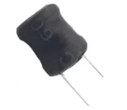

Figure 2 150uH inductor

1. Capacitor

Best selection for the capacitor is the capacitance equal to or greater than the calculated value. The output capacitor is chosen based on the required output voltage ripple and the load current. A suitable capacitor is selected based on its capacitance and voltage rating.

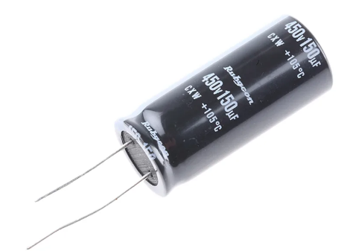

Figure 3 150uF Capacitor

1. MOSFET

IRF3708 MOSFET with a voltage rating and current rating greater than or equal to the calculated values as well as its on-resistance and switching speed is selected. The MOSFET should also have a low on-resistance and fast switching speed to minimize power losses. [2]

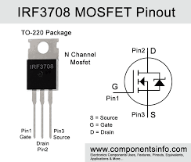

Figure 4 IRF708 MOSFET Pin out

1. Schottky Diode 1N5817

1N5817 Schottky diode is selected with a voltage rating and current rating greater than or equal to the calculated values. A fast recovery diode is recommended to minimize reverse recovery losses [3]. Based on these considerations, a Schottky diode is a good choice. Schottky diodes have a low forward voltage drop and can switch on and off quickly.

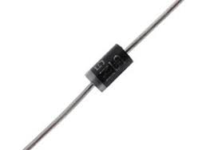

Figure 5 Schottky Diode

1. Resistive Load

In order to get 10 Ω resistance, we have utilized two 22 Ω resistors with each having a power rating of 10 watt. We make sure to connect the two 22 Ω resistors in parallel which ensures their resistance magnitude to be 11 Ω which is approximately close to 10 Ω whereas the combine power of 22 Ω resistors intends to be 20 watt.

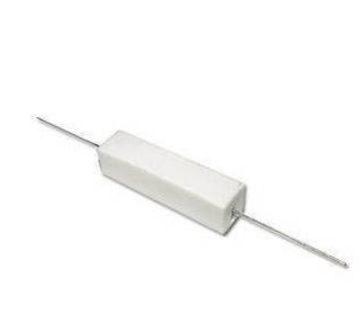

Figure 6 22 Ω resistor

1. Microcontroller

Arduino UNO is selected to control the gate driver and read the output voltage and current. The Arduino board provides an easy-to-use programming environment and a range of input/output (I/O) pins that can be used to interface with the gate driver. Additionally, the Arduino board is widely available and relatively inexpensive. Arduino is used with IR2110 gate driver to generate a PWM signal to control the MOSFET switching frequency and duty cycle. The PWM signal is generated using the Arduino's built-in PWM capability. Refer to Appendix C for code.

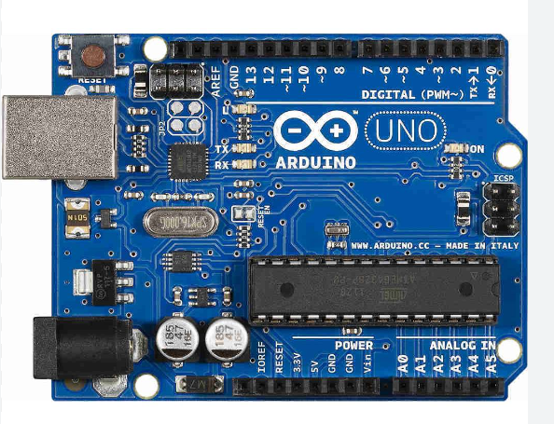

Figure 7 Arduino UNO

1. Gate Driver IC IR2110

The gate driver IR2110 is chosen based on its ability to drive the selected MOSFET, its voltage and current ratings, and its availability in the market. The IR2110 is a high voltage, high-speed power MOSFET and IGBT driver with independent high and low side referenced output channels [4]. It can drive both low side and high side switches in half-bridge and low bridge circuits. It is designed to operate in a wide range of applications that require high voltage and high speed switching. The IR2110 has a maximum supply voltage rating of 20V, which is well above the 5V supply voltage of the Arduino. Therefore, it can be safely used with an Arduino.

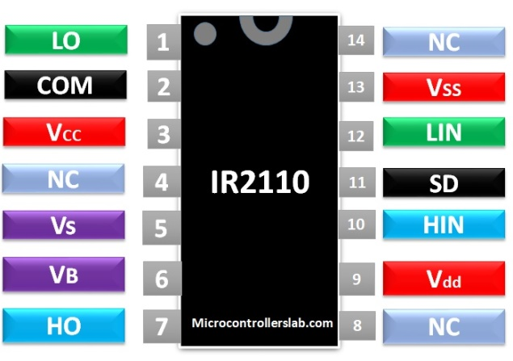

Figure 8 High Side Driver IC IR2110

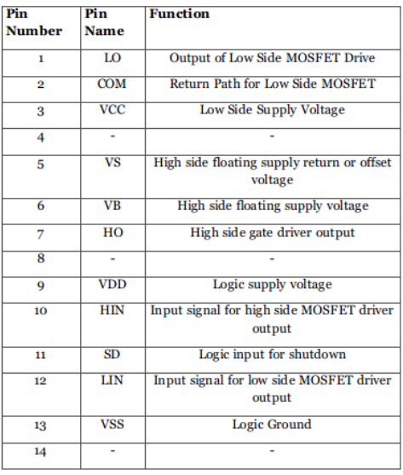

Figure Pin Configuration with functions

**V. SELECTION OF COMPONENTS**

Based on the design specifications as well as availability in the market following components are chosen with ratings checked in the data sheets:

|  |  |
| --- | --- |
| Selected Components | Values and Ratings |
| Inductor | **L = 150µH, rated for a current of at least 0.54 A (calculation in section III)** |
| Capacitor | **C = 470µF, rated for a voltage of 10V (as available in market)** |
| Resistors | **2 resistors of R=22Ω, P=10W** |
| IRF3708 MOSFET | **VDS = 11 V,**  **ID =Isw= 0.42 A (calculation in section III)** |
| 1N5817 Diode | **Maximum voltage rating of 20 V forward voltage drop typically around 0.45 V at a forward current of 1 A. [7]** |
| IR2110 Gate Driver IC | **Max supply voltage: 20V**  **[5]** |

Table Selected Components for Hardware

# **VI. SIMULATION FOR DC-DC BUCK CONVERTER**

The circuit was simulated using a PSIM simulator to verify its performance. This includes analyzing the voltage and current waveforms.

**CIRCUIT DIAGRAM:**

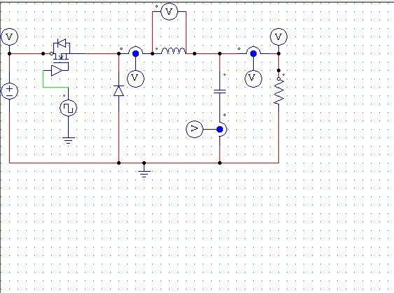

Figure 10 Buck Converter

**SIMULATION RESULT:**

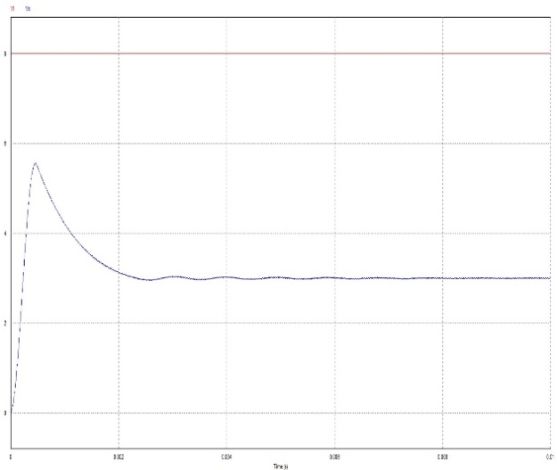

Figure Input and Output Voltage of Buck Converter

Waveform above represents the input and output voltage of the buck converter. The red wave indicates the DC input voltage, 8 V, while the blue wave indicates the output voltage, 3 V. Peak in the output waveform, initially, is due to charging and discharging of capacitor. Peak value is almost 5.5V. When the capacitor is charged then the stable DC output of 3V is obtained after settling time of 0.002 seconds as can be seen from the graph. Settling time is the time elapsed for an input to the time at which the output has entered and remained within a specified error band. It can be seen that settling time is minimized to a very low value. Therefore, it can be concluded that waveforms obtained are correct.

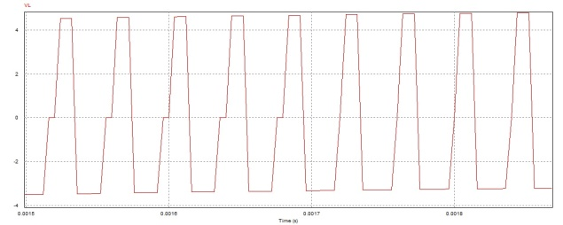

Figure Inductor voltage is varying from -3 to 5V.

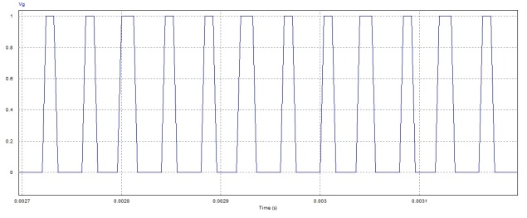

Figure High Side driver gating waveform varying from 0 to 1V

The above figures show the inductor voltage and high side gating waveforms simulated on PSIM with selected switching frequency and duty cycle of 37.5% respectively. The results as per requirement are obtained are confirmed to be correct.

# **VII. HIGH SIDE DRIVER CIRCUIT**

Figure 13 below shows the schematic for high side driver circuit that was developed on Proteus. Pin 10 is used for high side driving for MOSFET. A high side driver is manufactured to control the on-time and off-time of the MOSFET. The primary reason to implement a high side driver is to make sure that the protection features are present which can encounter situations such as over-current , short-circuit , and over-voltage to ensure the safety and reliability of the converter.

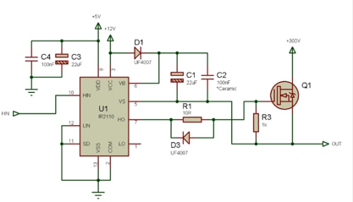

Figure 14 High side driver Schematic for IR2110

# **VIII. PCB DESIGN**

The circuit was designed and fabricated on Altium Designer. The circuit is laid out carefully to minimize noise and ensure proper grounding. Measurement points were made available to measure the high side driver gating waveform, voltage across the drain to source of the MOSFET, inductor voltage, and output voltage as shown in figure 15. The Schematics diagram was built for it followed by a PCB Layout process. *Refer to Appendix A for PCB layouts.* After executing these processes, this respective PCB was fabricated using various techniques such as etching, milling and printing. Successively the PCB was fabricated; it was populated with specified components manually. Finally, the completed PCB was tested to ensure that it functions as intended.

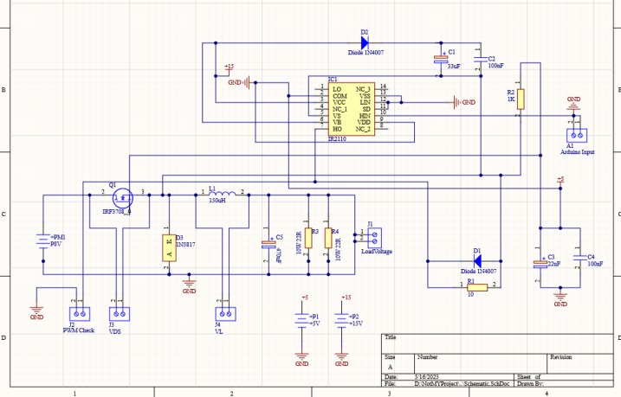

Figure Schematic on Altium Design for PCB

# **IX. TESTING**

After the fabrication of circuit on PCB, it was tested to verify its performance.

|  |  |
| --- | --- |
| Measurement points | Testing Results |
| High Side driver gating waveform |  |
| MOSFET Drain to Source Voltage |  |
| Inductor Voltage |  |
| Output Voltage |  |

Table Required Testing Results

# **XI. ANALYSIS OF RESULTS**

The measurement data was analyzed to determine whether the circuit meets the design specifications or not. Any discrepancies existing were noted, and possible solutions were implemented.

# **XII. CONCLUSION**

In conclusion, the design and implementation of a DC-DC buck converter has been successfully carried out, demonstrating its potential to convert an 8 V input to a 3 V output. The utilization of a 10Ω resistor load with a power rating of 20 W, combined with the achievement of an output voltage ripple of less than 0.5%, indicates the converter's ability to provide stable and precise power delivery. The high efficiency levels of buck converters, reaching up to 95% or more, have been leveraged in this design through the utilization of switching techniques to regulate the output voltage. This efficient operation minimizes power losses due to heat dissipation. Additionally, the implementation of a high side driver ensures the safety and reliability of the converter. The careful calculations and component selection, including the duty ratio, capacitor value, and inductor value, along with their voltage and current stresses, have been justified and specified to ensure optimal performance of the buck converter. The subsequent hardware implementation, carried out using Altium Designer to customize a PCB, followed by fabrication techniques such as etching, milling, and printing, has resulted in a completed PCB. The populated PCB has been tested to verify its proper functionality, ensuring that the converter operates as intended. Overall, DC-DC buck converters are reliable, efficient, and versatile devices that play a crucial role in various applications where a stable and efficient power supply is essential. Their ability to power sensitive electronic devices, ensuring precise and consistent power delivery, makes them an ideal choice for numerous electronic systems and circuits.

# **XIII. REFERENCES**

[1]<https://www.engineersgarage.com/articles-basic-electronics-properties-of-inductors/>

[2]<https://www.ti.com/lit/an/slyt664/slyt664.pdf?ts=1683304141357&ref_url=https%253A%252F%252Fwww.google.com%252F#:~:text=In%20general%2C%20a%20higher%20switching,t%20ignore%20the%20gate%20power>.

[3]<https://www.electrical4u.com/fast-recovery-diode/#:~:text=Because%20fast%20recovery%20diodes%20have,used%20in%20high%2Dfrequency%20applications>.

[4]<https://www.infineon.com/dgdl/Infineon-IR2110-DataSheet-v01_00-EN.pdf?fileId=5546d462533600a4015355c80333167e>

[5]https://www.infineon.com/dgdl/Infineon-IR2110-DataSheet-v01_00-EN.pdf?fileId=5546d462533600a4015355c80333167e

[6]<https://www.instructables.com/How-to-Control-a-MOSFET-With-Arduino-PWM/>

[7]<https://components101.com/diodes/1n5817-schottky-diode#:~:text=The%201N5817%20is%20a%20Schottky%20Diode%20with%20forward%20voltage%20drop,a%20forward%20current%20of%201A>.

[8]G. Dileep and S. N. Singh, “Selection of non-isolated DC-DC converters for solar photovoltaic system,” Renew. Sustain. Energy Rev., vol. 76, no. March, pp. 1230–1247, 2017.

[9] U. S. Ali, “Z-source DC-DC Converter with Fuzzy Logic MPPT Control for Photovoltaic Applications,” Energy Procedia, vol. 90, no. December 2015, pp. 163–170, 2016.

[10] M. H. Taghvaee, M. A. M. Radzi, S. M. Moosavain, H. Hizam, and M. Hamiruce Marhaban, “A current and future study on non-isolated DC-DC converters for photovoltaic applications,” Renew. Sustain. Energy Rev., vol. 17, pp. 216–227, 2013.

# **XIV. APPENDIX A**

# 

Figure 3D Model of PCB Design

# 

Figure PCB Design Schematic

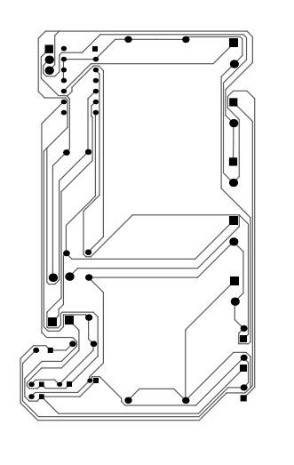

Figure PCB for fabrication (printable form)

# **XVI. APPENDIX B**

Arduino Code for generating PWM at high side with switching frequency and duty cycle:

const int PWM_PIN = 9;

const int PWM_FREQ = 25000;

const int PWM_DUTY_CYCLE = 128; // 255 * 0.375 = 96.56 -> rounded to 128

void setup() {

// Set PWM frequency and resolution

TCCR1A = _BV(COM1A1) | _BV(WGM11);

TCCR1B = _BV(WGM13) | _BV(WGM12) | _BV(CS10);

ICR1 = F_CPU / (PWM_FREQ * 2);

// Set PWM duty cycle

OCR1A = PWM_DUTY_CYCLE;

// Set PWM pin as output

pinMode(PWM_PIN, OUTPUT);

}

void loop() {

// Do nothing

}